MURVI MORELLO

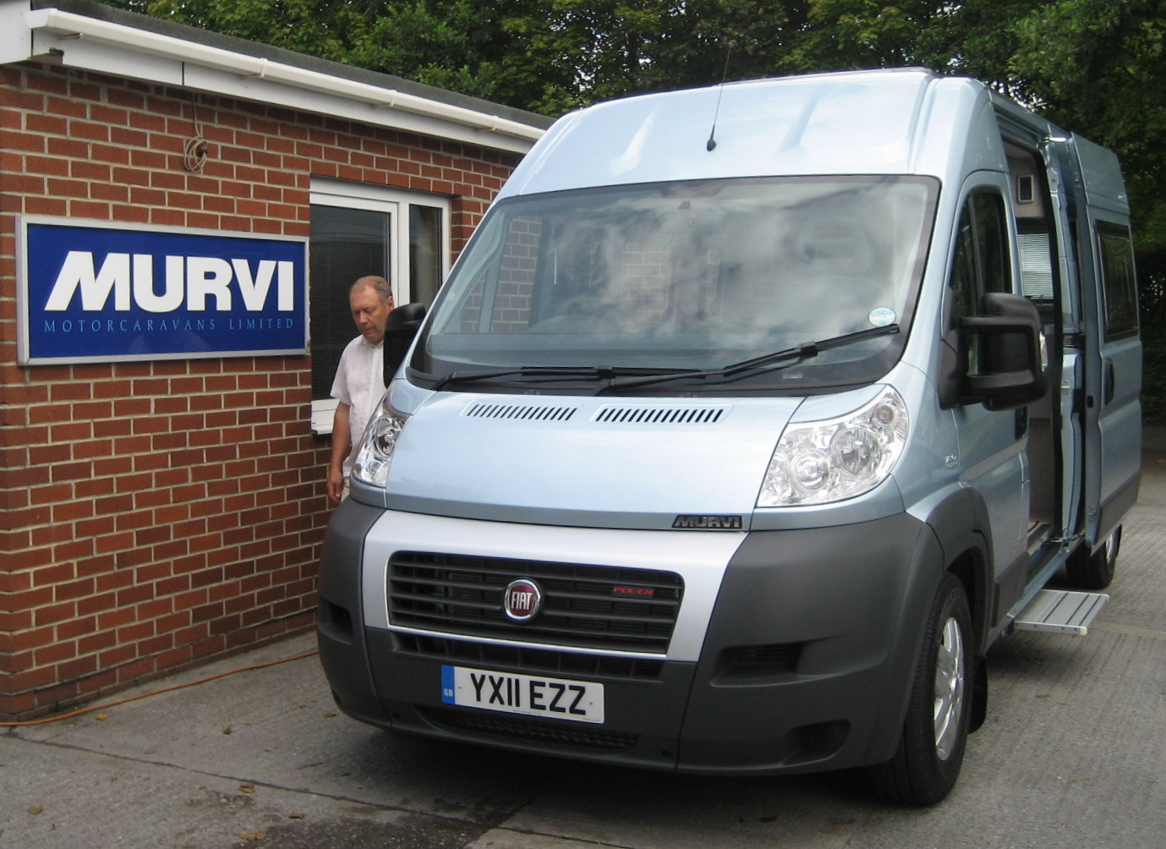

INSTRUCTION MANUAL
Contents
The Fiat Vehicle Dimensions | 3
Keys | 3
Driving | 4,5
Utilities Electricity | 6,7
Gas | 8
Water | 8
Heater | 9
Windows Opening | 10
Blinds | 11
Living Room Seating | 12
Carrying Passengers | 12
Beds | 13
TV | 14
DVD | 14
Kitchen Fridge | 15
Hob | 15
Extractor Fan | 16
Microwave | 17
Washroom Toilet | 18
Before Setting Off | 19,20
Setting Up On Site | 21
Where is Stuff Kept? | 22
FAQ | 23
Dimensions

Height | 2.57m | 8.5 feet
Length | 6.0 8m | 19.7 feet
Width with wing mirrors | 2.48m | 8.2 feet

Van Keys
There is a Fiat key and a Gemini fob for the burglar alarm. The alarm gives extra security to Thatcham Cat 1 level.
The Fiat key has three buttons. The top one opens the driver’s and passenger’s doors. The bottom one opens the sliding and rear door. The middle button locks all the doors.
To use the Gemini security system first lock the van using the Fiat key and then press the part of the fob button with the dimples. After you press the fob there is a two second delay then you hear two beeps.
When you unlock the van press the dimple button on the fob to disarm the alarm – you will hear three beeps- before opening it with the Fiat key.
The little fob with 2 small prongs is a key to turn off the burglar alarm in an emergency. It fits into a place on the dashboard.
Driving
Setting off
Before setting off go through the checklist to prepare the van. Then before you start the engine turn on the sat nav. This will activate the reversing camera.
Wing mirrors. Each wing mirror is each made up of two mirrors. The top one is norma, the bottom one is convex to give a wide field of view. Both halves of each side mirror can be adjusted electronically. I found that if you have the mirrors pointing in more than you would usually – so you can see more of the side of the van – then this allows you to see the car behind. (You cannot see the bottom of the mirror on the passenger side as it is behind the window blind.)
To start the engine turn on the ignition. The van may start to beep. There are a number of reasons that the van may beep at you:
- Step not put away
- Doors not closed – if the mileage screen shows a door, then one is open.
Wait until the engine heater switch has gone out. Although do not wait too long as he engine will be cooling down undoing the benefit of the heating process.
Press your foot on the brake. The van might be indicating that it is gear;however when you start the van will automatically go into neutral. You need to press the gear lever over to A/M to go into automatic. To drive in automatic that’s it.
Reversing
Before you start if it’s possible take a walk round the back of the van to work out which way you are going to manoevre. Whenever possible use somebody to help you (open the window so you can hear them!) You can use your wing mirrors and your reversing camera. Tell the person helping you that thy can signal to you via the reversing camera. To put the van into reverse push the gear lever towards R.
Gearbox
The van will drive in automatic without any manual gear changes. However, It is possible to self-select gear changes by pushing the gear lever forwards to change down and backwards to change up (imagine changing from 3 to 4 in an ordinary car.)
The van will change up at about 2,000 revs (higher if you are going up a hill), it will change down at 1300 revs. If you are at 1,800 revs it can be worthwhile to accelerate to 2000 revs and force it to change up and then decelerate to the same speed. Better still you can press the gear lever to change up the gear. If you are at the wrong revs to change up then the van will beep, you have to move the gear lever to stop the beep, even though it never changed in the first place.
When you brake the engine will usually change down a gear. You can manually change down a gear. This is helpful in controlling the van coming down a steep hill using the low gears.
There is a button called the UP button. This is on the dashboard by the gear stick. It looks like a van with a weight on it going up a hill. The purpose of the button is to tell the van to change up at higher revs thus improving the acceleration, although worsening the fuel economy. It is easier to drive in this mode.
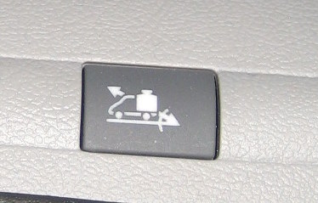
Cruise control
Turn the cruise control knob (CC) to ON. The information screen will indicate that CC is on. Accelerate to the desired speed and then move the CC stalk towards you. This will set the CC speed. Pull the handle towards you to decrease the speed and push it away from you to increase the speed. One touch of the knob changes the speed by 1mph. When want to turn the cc off press your foot lightly on the brake. I find it useful not to be in CC when you are approaching a potential hazard like congested traffic or a motorway junction. When you want to resume the same speed as before press the knob at the end of the CC stalk and the van will accelerate to the same speed.
Instead of using the brake to turn CC off you can turn the knob on the CC stalk to OFF. When you turn the CC back on again it will have forgotten your previously set speed and so the resume speed knob has no effect.
Overtaking
The main issue here is the length of the van. When overtaking keep looking at the vehicle that you are overtaking in the side mirror. To be absolutely sure that you are past the vehicle -wait until you can see them through the back window.
Parking strategy.
Good places for parking: supermarkets, leisure centres, and parking lots outside the centre of town. If bays are marked out you may have to park in two bays and be obliged to pay for two places.
Check carefully for height restrictions and height restrictions at the entry to car parks. The height of the van is 9 feet, 2.75 metres. You will not probably not fit in a multi-storey carpark.
Parking in a car park. Wherever possible park well away from the busy areas to give yourself lots of room. Back in when you arrive so that other cars can not box you in and you have an easy get away.
Always have a person outside to guide you. Use your two side mirrors and reversing camera. The easiest way to see the person directing you is to use your rear view camera.

Electrical system.
The van has both 240 volt and 12 volt circuits.
1. Mains (240 volt)
The 240 volt system is powered by an external source point. When the van is connected to the mains a red light will come on in the rear corner of the van by the microwave (this is covered in tape so it is not a nuisance at night).
There is a circuit breaker in the wardrobe.
There is a fuse box in the wardrobe.
There are four 240 volt (3 pin) sockets – one above the fridge, one behind the sliding door, one on the floor behind the driver’s seat and one in the wardrobe. If you are not connected to the mains you cannot use the sockets: they do not work on the batteries.
The microwave works only on mains .
The fridge can work on mains if you set it to this.
The heater can work off mains.
The rest of the electrical equipment in the van works on the 12 volt system supplied by the leisure batteries; but the batteries can be charged by the mains.

2. Leisure Batteries (12 volt)
The 12 system is supplied by two leisure batteries which are housed in a box behind the double seat . The battery which is used to start the van’s engine does not supply power to the interior of the van, so you cannot flatten the engine battery by using interior appliances, although the engine battery does charge the leisure batteries when the engine is running.
The mains also charges the leisure batteries, so you may have to connect to the mains every couple of days.
The step, lights, TV, Satnav and water pump all work off the 12 volt system.
The fridge and heater do not work on the leisure battery system.
There are three 12 volt sockets (cigarette lighter type): one at the rear of the dliding door, one on the passenger side pillar and one on the dashboard.

12 volt power controller – (called cbe) (blue console by the TV).
cbe is the manufacturer’s name.
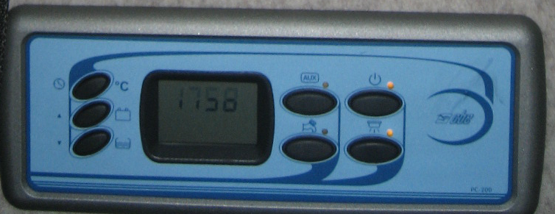
There are seven buttons to the left and right of the display panel
Right | Top | Clock and internal and external temperatures | Press button gives external and internal temperatures  Press and hold the button allows you to set the clock. Use the battery and water level button to change the hours and minutes.
 | Middle | Battery condition | Gives the voltage and current being taken from the van and leisure batteries.  The leisure batteries are indicated with a picture of the cabin of the van.
 | Bottom | Fresh water level | Gives the level of the water as a % of the maximum volume.
Left | Top left | 12 volt sockets | Auxillary system – button labelled AUX
 | Top right | ON/OFF for the whole 12 volt system | Master button
 | Bottom left | Water pump ON/OFF
 | Bottom right | Lights ON/OFF | All lights run on 12 volts

The screen also gives warning indicators for grey water – 80% full.

Gas
The gas tank is slung under the chassis of the van. It is filled via the Autogas point from an LPG refilling point at a petrol station. The tank contains 20 litres but do not fill it more than 80% to allow for expansion.
The amount of gas in the tank is indicated by a series of lights on a black plastic screen on the dashboard in front of the driver ( called Lektron). The level is only indicated when the engine is running.
If filling up abroad use one of the continental adaptors kept under the single seat.
To turn the gas off use the valves in the narrow cupboard under the sink. There are two valves – one for the fridge and one for the cooker.
On cross channel ferries they insist you isolate the gas. They may be content with isolation at the two valves under the sink. However they may insist that you isolate at the tank. To do this you need to undo the plastic cover on the gas tank to get to the valve. Isolation prevents leakage of gas if any of the pipes are ruptured during transit.

Water System
The fresh water tank is next to the fridge and can be accessed via the rear door. The tank is filled via the port at the back of the van on the passenger’s side. The port is marked with a picture of a blue tap. Put a hose into the hole and fill until the water overflows. The CBE system tells you how full the water tank is. The system holds 16 gallons .
The water pump switch is on the cbe panel.
The water system is pressurised. This means that the water will flow from the taps for a little while with the pump off.

The waste water from the sinks and the shower tray go the the grey water tank which is slung under the van chassis. The cbe panel will indicate when the grey water is 80% full.
The grey water is emptied via the valve with a red handle on it. At some campsites you can park over a drain and open the valve and the grey water just drops straight down the drain. At other campsites you will have to connect a pipe to the valve to reach the drain. At some campsites you may have a drain at your pitch. In this case you can have the grey water valve open all the time and continuously connected to the drain. In extremis you can offload the grey water without a drain. The water is only contaminated with a little soap – environmentalists recommend that in times of drought gardens are watered with grey water.

Heater
The heater heats the water for the kitchen and wash room taps and the shower. It also heats the inside of the van using hot air that comes out of three ducts. The heater can run on 240 volts or diesel.
The controller is to the left of the TV and has got the manufacturers name on it: Wabasto.
Press the ON button- this is on the left hand side.
When you are connected to the mains use mains as the preferred fuel. When you are not connected to the mains the control panel indicates that it has detected no mains and shows a plug with a line through it. With no mains the the heater will use diesel automatically.
Press the menu button to get a list of heating options. Use the arrow buttons to scroll through the options. The three options for simple heating are:
- Heating cabin only
- Hot water only
- Heating cabin and hot water
Water temperatures of 40C and 70C can be selected. Choose 70C for normal hot water. The desired cabin temperature can be set with up and down arrows on the right hand side.
After you have programmed it press the start button. The red light on the panel will come on.
There is a warning light on the dashboard in front of the driver to indicate that the heater is on.
There are a number of options concerned with having the heater come on at selected times. You probably won’t want to use these. (If you do see the Wabasto leaflet)
To keep the water hot you need to have it on water heat all the time. It just uses a small amount of power to keep the water at 70C.
You can heat the inside of the van with hot air even if you have no water.

Windows
To open the windows:
Main roof window – wind the handle.
Kitchen roof window – turn the cream knob
Bathroom roof window – push up 1 or 2 handles
Large side windows – these open outwards from a top hinge..
To open these use the 4 black handles. These have a lock button which comes on automatically when the window is shut. Press the button to release the lever. The lever should then work easily. If you find that it is difficult to use then you are doing it wrong. Don’t force them or they could break. When you have released the levers push the windows open until they click and then they will stay open. There are two opening positions. To lower or close the window push the window a little more open. This will release the catch and allow you to lower the window.
Small sliding windows
The sliding windows also have a lock on them. This does not come on automatically.
Window blinds and fly screens
For the opening windows- to raise the blind squeeze in the grey catches at the middle of the blind. This will pull the catch rods away from the runners at the side of the window. There are a number of steps in the runners that hold the ends of the rods and allow the blind be set at different heights by releasing the central catch.

For the blinds to catch at the sides the rods have to be exactly in the middle. It is possible for the rods to get offset from the middle, resulting in only one rod catching properly. You can see that this is happening because the push rods in the middle move by different amounts. This problem can be rectified by re-centralising the middle of the rods.

The flyscreen can be used with the windows open to give a breeze without letting in insects.
To use the flyscreen pull the slide all the way to the top and connect the blind to the fly screen. The metal edge at the top of the blind has to be pushed into the opening in the fly screen. There are two grey catches on the fly screen that will hold the blind and the flyscreen together. The blind and the flyscreen can now be moved together.

To disconnect the flyscreen from the blind push the blind up to the top of the window and then disconnect the flyscreen by pressing in the two sliding catches. The prevents the flyscreen from being violently retracted as it would be if disconnected from the blind at the bottom.

For the sliding windows - the blinds and flyscreen on the sliding windows work similarly to the opening windows. However, they have a central connection between the blind and flyscreen rather than the two catches on the larger opening windows.

The driver’s and passenger’s side windows – these have just blinds with no flyscreen. These are raised by pulling back the plastic slider on the top of the blind. This releases the blind from the front catch. Raise the blind fully. The blind attaches to the door by a magnet on the blind. To allow the magnet to reach the door you have to move the slider down.

The front windcreen – this has a blind. To raise this first straighten the rear view mirror so it does not get in the way of the blind. At the bottom of the dashboard in the middle is a clip holder. This will get in the way of the blind. To move it out of the way put something under the clip to move the clip forwards. Pull up the blind. There is no catch at the top it is held in place by friction.

All roof windows- these have blinds and flyscreens. These work independently of each other. For the main roof window DO NOT have the blind fully closed when the window is closed during the day as this can cause a heat build up which could buckle the roof window.

At night you can have the blinds fully up to exclude the most light. If you dont want to use the front blinds you can use the curtain that goes across the cabin. It is kept over the cabin and it hooks on to the crtain rail.

During the day you can use the flyscreens to give some privacy from people outside looking in. We leave them like this.

Seating
Drivers and passengers seats.
These can be swivelled round.
For the passenger’s seat move the seat as far forward as possible. This allows the seat to spin without hitting the van. Pull up the handle at the right hand side and swivel.Then push the seat as far back as possible. Drop down the foot support .
The brake handle prevents the driver’s seat from swivelling freely. Therefore it is necessary to put the van in gear and take the handbrake off. The seat can then be swivelled like the passenger seat. Put the handbrake back on when the seat has been swivelled. With the main seating in the side bench configuration and the drivers chair swivelled round fully there is no room for your legs. You should swivel it to face partly towards the passenger’s seat.
We swivel the passenger’s seat but not the driver’s. We fold down the back of the driver’s seat so it becomes a backrest for someone sitting on the bench seat (eg to watch TV.)
Double seat
The double seat can be faced forward or backwards as well as sideways.
The single seat (corner section)
This can be made longer to seat two people – pull it out and infill with the back rests.

Carrying passengers
To carry passengers move the double seat to face the front. To make it secure it needs to be bolted to the floor. Prop up the front of the seat and position the so that the bolt holes are over the two stainless steel rings on the floor. Use the ratchet bolts to secure the seat. These are kept in the base of the seat. Pull up the handle to engage the ratchet. Push down to free from the ratchet. Pull out all the seat belts.
There are two three point belts- one on the rear seat and one on the bench . There are two lap belt straps on the double seat.

Sleeping
Main bed
Before making the bed fold down the kitchen counter by the door, so you have more room to manouevre.
The bed is made of two sections; the double seat and the single seat both pull out.
The bed is created as follows: First the catch which holds the double seat in place needs to be released. To do this lift the front of the seat base and prop it up with the stay on the left hand side. The catch has a red knob and slides through to the wood and prevents the double seat from moving. Open the catch.
Slide the base out. To move the base easily on the runner and to avoid damage keep the base straight as you pull it out. Lift the front of the seat up and then pull it forwards to flatten it out. Turn over the large cushion that was behind the back of the seat and put it into the gap. Then push the bed back.
Then pull out the single seat. Firstly remove the back-rest cushions that are not clipped to the wall and dump them in the cab, then pull out seat (with the steel support) then drop in the infill cushions. The infill cushions are the two back rest cushions that were clipped to the wall.
This configuration allows you to sleep longways down the van with a large bed.
To change the bed back to a seat. First pull the bed forward to release the large cushion at the rear. Store this on its end. Raise the front of the bed until it clicks and then lower it. This should raise the back of the seat. Locate the base in the runner and push back into position. To lock the seat in place prop open the front of the seat and turn the lever to push the rod into the fixed section.
When going to bed it is easier if you pull out the double seat, then get undressed, then pull out the single seat. When the bed is fully made you will have nowhere to stand, but with the single seat not pulled out you will still have a square of floor available. In the morning push back the single seat at once so you will have enough floor space to get dressed andyou can use the kitchen or bathroom before putting away the rest of the bed.
When the bed is fully out you may find it more convenient to exit the van via the toilet door (!)
Bed over the steering wheel (suitable for a child)
Before installing this bed turn the driver’s and passenger’s seats so their backs are against the side windows.
The bed is made of two metal bars and material that hangs between them like a hammock. There are metal brackets at each side of the cab that support the rods. The front rod is the longest ,so identify the longest rod and slide it into the front brackets. Then slide the rear rod into its brackets. Take care not the scratch the van. The bed is a little difficult to get into. It is also hard it needs something soft to sleep on - either foam or a duvet.To stow the bed roll it up, put the front into the holder and then fasten up with the ties.
Stow your bedding over the cab.
TV
To use the TV switch on the power at the TV switch. The 12 volt system needs to be live so ensure that is turned on at the cbe panel.
The external aerial can be positioned from inside the wardrobe. If reception is poor the aerial can be raised by loosening the bottom white plastic nut, raising the aerial, and then tightening. If reception is still poor the aerial can be rotated. Slacken off the lower nut, rotate and then retighten. The vertical angle of the aerial can also be changed by twisting the bottom of the aerial support.
Usually at a new site you need to go through the autoscan routine to retune the channels..
The TV remote controller is on the shelf under the window by the TV.

DVD player
To play a DVD. Switch on the Satnav and the TV at the two switches to the side of the TV.
Switch on the Satnav on the console in the dashboard. This takes some time to come on.
Put a DVD in the DVD player. The DVD should start automatically.
With the TV controller use the INPUT button to select AV on the TV screen.
The DVD remote controller can be use to control the DVD player. Switch the DVD remote controller to DVD (the little switch at the side) Press AV out. The buttons that control DVD functions are marked red.
Point the remote at the dashboard console (the satnav) not at the TV.
The DVD remote control is on the shelf under the window by the TV.
Fridge
The fridge can run off mains, 12 volts or gas. The choice of power is not automatic, you have to tell the fridge what power source to use by using the MODE button on the fridge..
At the campsite
With the van plugged into the mains at the campsite use the MODE button to switch to mains power.
If you are camped without mains run the fridge on gas. (You are not permitted to run on the leisure batteries as this would be high a load on the batteries and run them down too quickly. )
When running on gas – if the fridge does not get cold this is because the gas has not ignited. Press the on/off button 2 or 3 times to get it to ignite.
When driving
When you are setting up the van for a journey press the MODE button to move to 12volts The fridge is powered by the van engine and does not use power from the leisure batteries.
You can set the temperature of the fridge with the other button. The temperature is indicated by the vertical strip of lights.
At the back of the van there is one door which is the toilet and one which is the back of the fridge. There should be no need to open the door behind the fridge except for maintenance. If you do, be careful as the exhaust from the gas cooler for the fridge is a pipe that has to fit into a hole in the rear door. Be careful to get it in the right place before you close the door. To confirm the fridge is working check that the exhaust pipe is hot.
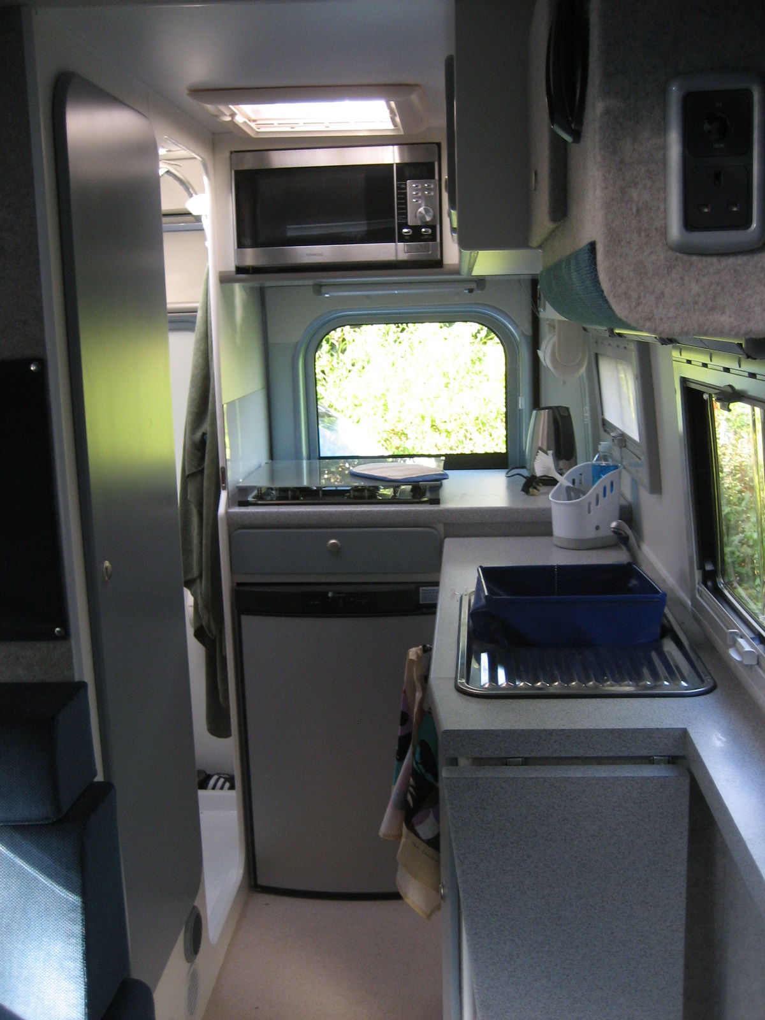
Cooker Hob – Gas.
There are four gas burners and a grill below.
To start the burners turn the knob and hold it down. Press the ignition switch to light the gas. Hold the knob down for a moment to ensure tha the gas stays on.
Grill – use the gas grill in preference to the microwave grill which is too high up. With only the grill pan under the gas grill the flame is a long way from the cooking surface. Put something metal under the grill to raise it.
To boil the kettle if you are on mains use the electric kettle. When you are off mains use the whistling kettle on the gas hob.
Wait until the gas hob has cooled down before putting the cover back on top of the gas hob.

Extractor fan
There is an extractor fan over the hob. It works on the 12 volt supply.
To use it first open the roof cover above the fan to give the air freedom to move. Press the button in the middle to turn it on. Press the side buttons to either exptract or suck in air. Repeatedly pressing the buttons will increase the speed.
I found that once it got stuck on speed 6 extract. I managed to reset it by turning the fan off and then turning it on again with my finger on the suck in button. (It may have been a fluke)

Microwave
The microwave only works when you are attached to a 240 volt supply. There is an on switch for the microwave behind the 240 volt socket at the back of the van.
The microwave is 800 watt. Power settings available are: 100%, 80%, 50%, 30%, 10%.
The two most useful function of the microwave are as follows:
- Setting the power level and time. This allows various power settings for various times.
For example: to use 80% power for 18 minutes
- Press the micro/grill/combi button and the display will show P100 (power at 100%)
- Turn the time/power/weight dial to change the power 80% (marked P80)
- Press the micro/grill/combi button to confirm the power level (You’ll probably always want to microwave at 100% power. In this case press the micro/grill/combi button with the power display showing P100.
- Turn time/power/weight dial to set the cooking time. The time is displayed first in 5 second intervals until xx minutes is reach and the in incremenrts of xx and finally in increments of xx. Adjust the cooking time until it shows 18:00 (18 minutes – 18 seconds would be 00:18 and not a time you can programme)
- Press the start/express cook button to start cooking.
- Press the stop/clear button once to stop and hold cooking. Press again to restart cooking.

- Quick start
This feature allows you to cook for intervals of whole minutes at full power.
- Press the start/express cook button. This will give you one minute at full power. Press the button again to add more minutes.
This feature is a good way of cooking for a small number of minutes.

The microwave has a grill. However as it is quite high to reach we would reccomend that you use the gas grill under the hob.
The microwave offers many other operating options, which you probably won’t want to use. However if you do see the manual.
Toilet
The toilet is a SOG system that does not need chemicals. The smell is taken away by a fan and so the 12 volt system needs to be on for the fan to operate .
To use the toilet first open the waste hole by pulling the grey handle at the front of the toilet. With the 12 volt system on you will hear the fan come on. After you have finished, flush the toilet by pressing the central button and then close the waste hole.
There are warning lights on the toilet. One indicates that it is 80% full, one that it is 100% full, and one indicates that the cassette has been removed for emptying. The fourth light is not used as it is only relevant when the toilet has its own source of water. The lights only work when the 12 volt system is on.
To empty the toilet: open the outside toilet hatch (marked SOG) with the key. This will release the handle. Turn this to open the door. There is a pipe that connects that waste tank to the extractor fan take this out and replace it with the bung. To empty the toilet take the cap off the exit pipe and pour out. There is an anti-vacuum button at the back of the cassette. Press this to get a smooth flow. Rinse the cassette a couple of times.
When reinstalling the toilet replace the tube to the extractor fan. Relock.
We would recommend that whenever possible you use the campsite toilet. If you are using the van toilet try to empty the cassette once a day as it can get quite heavy.
We keep silicone gel below the casette for use on the seal if there is a leak.

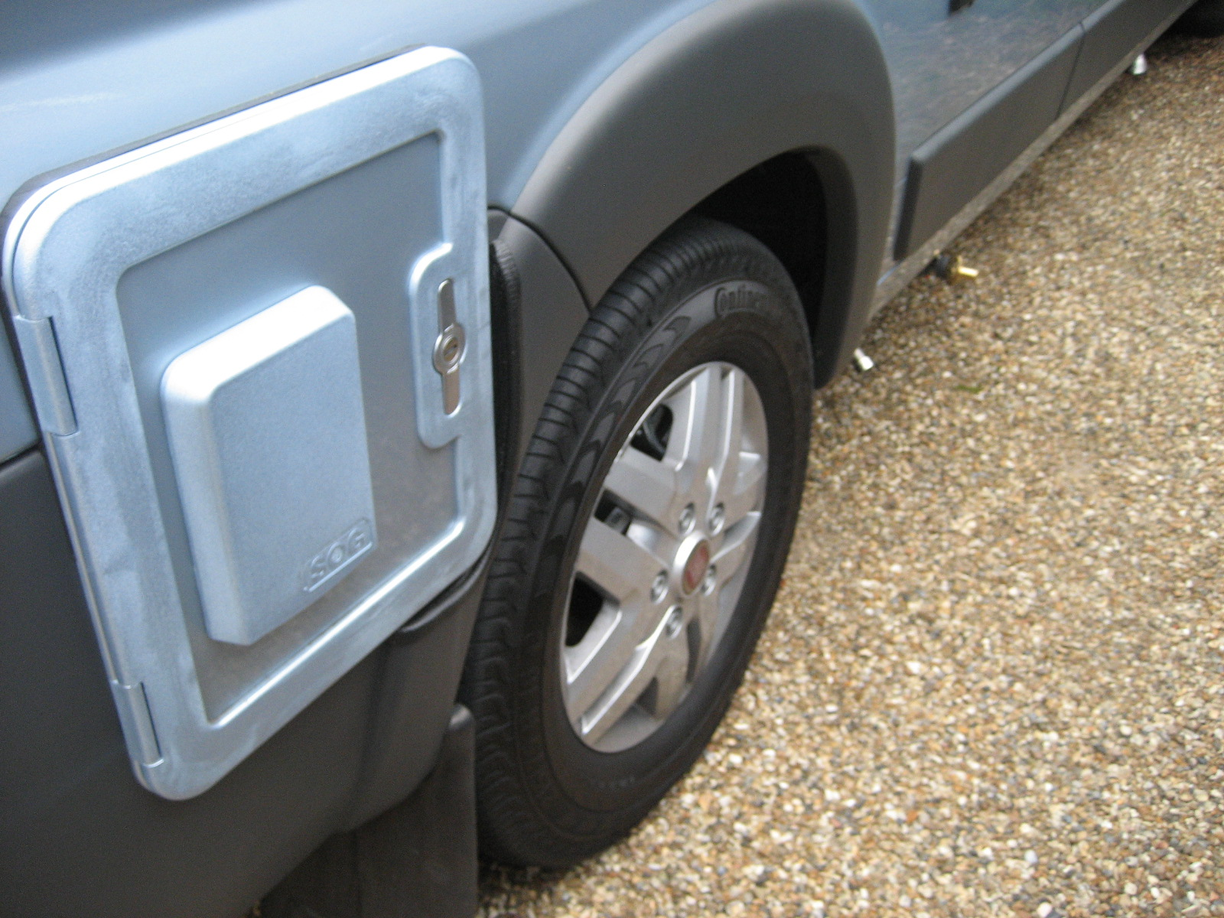
Toilet access door
Grey water valve
Exhaust ipe for deisel heater
Before driving off:
Disconnect the mains cable (if used) – stow it in the van.
Disconnect the waste water pipe (if used) – stow in same place as electricity cable. The waste water pipe should have the brass connector on the end of it;don’t leave the brass connector on the end of the outlet as it could fall off.
Put up the step – If you do not put the step up the van beeps as you turn the ignition. The switch for the step is on the passenger side pillar underneath the seat belt.
Put the plug in the shower tray (under the carpet.). The plug is often up as it pops up if someone treads on it. When the van is being driven the water in the grey water tank will slosh around and come up up into the shower tray if the plug is not in.
Close all the widows. Close the three roof windows: main, kitchen fan, and bathrom as well as the side windows.
Lower the TV aerial and point it in the direction of the van to reduce wind resistance. The aerial is pointing forwards when the rivet is pointing towards you. (The aerial is in the wardrobe.)
Switch the fridge to battery power by pressing the mode switch. The fuel setting is indicated by a light. .
Close down the 12 volt system completely by pressing the on/off button on the cbe panel. The fridge will work off the van engine electrical system.
Turn off the TV switch.
Turn ON the swich for the Satnav. This is to the left of the TV underneath the TV switch. The radio, satnav and reversing camera will not work if the Satnav switch is not on.
Open the blind behind the cooker. This gives you visibility through ther back window. For short journey you do not need to fully raise it. However, if the sun catches the blind it can cause glare preventing you seeing through the window. If you are going a long way raise the blinds to improve visibility. To raise the blind carefully twist the bottom of the blind off the catches.
Lower the hob cover.
Dont leave anything lying about. Make sure the stuff on the shelves and in the fridge is properly stowed.
Close all the cupboard doors and press the knobs in. Close or fix open the toilet door as preferred
Optional for long journeys:
Turn the gas off at the taps in the narrow cupboard under the sink. The fridge gas can be turned off as the fridge runs on 12 volt power from the van.

Before driving off checklist:
Disconnect mains
Disconnect waste water pipe
Put up the step
Close all the side widows. Close the three roof windows. Open all the blinds
Lower the TV aerial and point it in the direction of the van
Switch the fridge to battery power
Turn off the TV switch
Turn ON the switch for the Satnav
Turn off 12 volt system
Ensure all items are well stowed.
Close all the doors and press the knob in. Secure the toilet door
Open the blind behind the cooker
Lower hob cover

Setting up on site:
Try to park on level ground. If the van is not level you will be uncomfortable and the sink might not drain.
Put out the step.The button for this is on the passenger seat door pillar , under the seat belt.
Connect to the mains . The cable is kept under the seat by the TV.
Switch fridge to mains if you can, otherwise to gas.
Switch off the Satnav if you are not using the console to play DVDs or CDs.
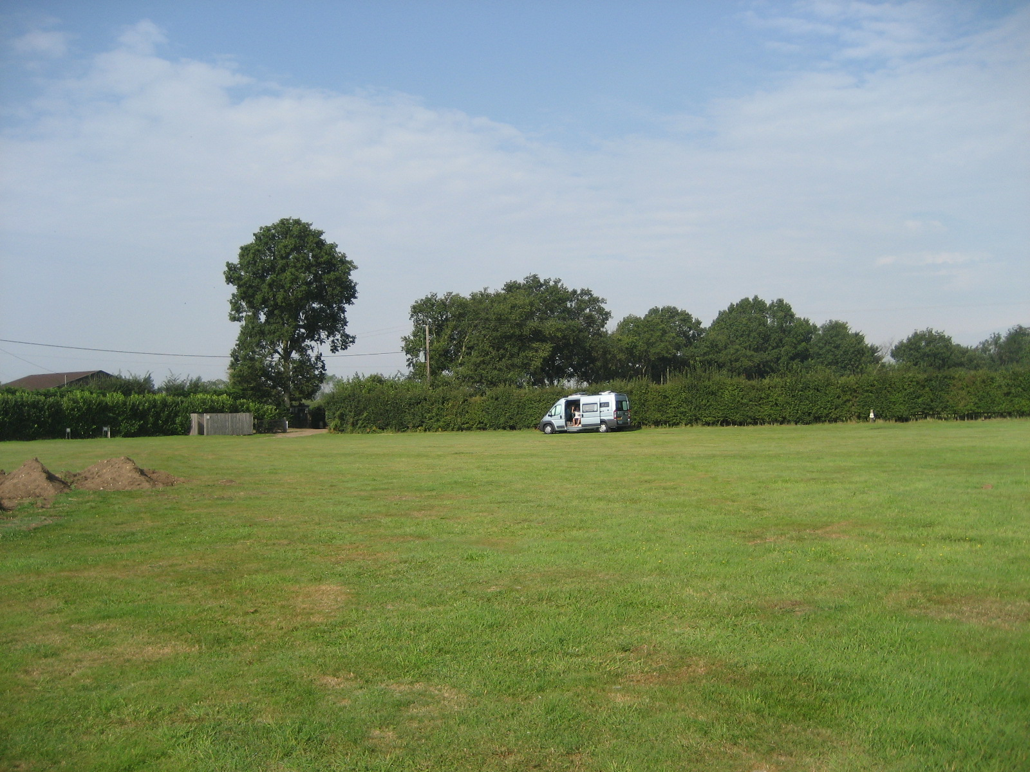

Where Stuff is Kept.
Safety equipment
Fire Extinguisher | In passenger door - lower pocket
Fire Blanket | In wardrobe
First Aid Kit | In bathroom cupboard
Warning Triangle | In box on floor behind double seat
Smoke alarm | Above driver’s seat back rest
High Vis jackets | In front of passenger seat

Repairs
Assorted tools eg screwdivers, WD40. | Under driver’s seat
Spare lightbulbs | In wardrobe in small white box on back wall
Spare fuses | In blue Murvi bag, behind driver’s seat  drivers  driver’s seat
Jack | Under single seat
Velcro, pins, tape etc | In cupboard by driver’s head

Miscellaneous Equipment
Barbecue | Under single seat
Chairs | Under double seat
Clothes airer | At bottom of wardrobe
Curtain | Over cab
Handles for fixing double seat to floor | On the floor of the double seat
Hose for waste water | Under the single seat
Hose for clean water | Under the single seat
Toilet Key; Water key; Safe key | Stuck with Velcro inside overhead cupboards.
Mains cable | Under the single seat
Ramps | At back of wardrobe
Washing line and pegs | In bathroom lower cupboard
FAQ
What is the beep when I try to drive? The step is out. Or the door is open.
Why doesn’t the reversing camera work? For the reversing camera to work you need to have the Satnav switch down (the switch is to the left of the TV). Then press the power switch on the Satnav (it takes a couple of seconds to lght up). Start the engine and put it into reverse gear.
What is the light at the back of the van next to the microwave switch? This indicates that the van is plugged into the mains.
Why is there is water in the shower tray which has wet the carpet? You have driven the van without the plug being in. Water has sloshed up from the grey water tank. Put the plug in whilst driving.
Why are the window catches difficult to move to open the window? All the catches have locks on them. For the windows that open press in the button. For the sliding windows make sure that the lock button is down
Why is it is difficult to connect the blind to the flyscreen? Make sure that the metal tongue on the blind slides into the opening on the flyscreen. The two blinds should then click together.
Why is the floor soft betwen the drivers and passengers seats? This is the structure of the van. The sponge under the floor cover is to protect the items underneath. Ignore it.
What is the strobing light by the sliding door? This shows the carbon-monoxide detector is working.
Why can’t I flush the toilet? The water pump is not switched on. The switch is on the cbe panel by the TV.
Why is there no hot water? The heater is not switched on. The switch is on the cbe panel by the TV.

Where is the cutlery? In the lower cupboard next to the fridge. The cutlery tray slides out from under the top shelf.

